ASSIGNMENT NO.5: Aggregate Functions and Data Analysis

Student Name | Aayan Sayyed | Roll Number | 20963
Batch | SY. BSc Data Science | Topic | WB(Assignment-5)

Q1) Create a MySQL database named CollegeDB and a table named StudentResult.
The table should contain the following columns:
Column Name | Data Type | Constraint
StudentID | INT | PRIMARY KEY
StudentName | VARCHAR(50)
Course | VARCHAR(30)
City | VARCHAR(30)
Marks | INT
FeesPaid | DECIMAL(10,2)
Insert at least 10 records into the table

QUERY:

CREATE DATABASE CollegeDB2;
USE CollegeDB2;

CREATE TABLE StudentResult (
StudentID INT PRIMARY KEY,
StudentName VARCHAR(50),
Course VARCHAR(30),
City VARCHAR(30),
Marks INT,
FeesPaid DECIMAL(10,2)
);

INSERT INTO StudentResult (StudentID, StudentName, Course, City, Marks, FeesPaid) VALUES
(1, 'Rahul Sharma', 'BSc IT', 'Mumbai', 78, 45000.00),
(2, 'Priya Patil', 'BCA', 'Pune', 85, 40000.00),
(3, 'Aman Verma', 'BSc CS', 'Nashik', 67, 42000.00),
(4, 'Sneha Joshi', 'BSc IT', 'Mumbai', 91, 45000.00),
(5, 'Karan Mehta', 'BCA', 'Thane', 74, 40000.00),
(6, 'Neha Shah', 'BSc IT', 'Pune', 88, 45000.00),
(7, 'Rohan Desai', 'BSc CS', 'Mumbai', 69, 42000.00),
(8, 'Meera Kulkarni', 'BCA', 'Nashik', 82, 40000.00),
(9, 'Arjun Nair', 'BSc IT', 'Thane', 59, 45000.00),
(10, 'Divya More', 'BCA', 'Mumbai', 93, 40000.00);

OUTPUT:
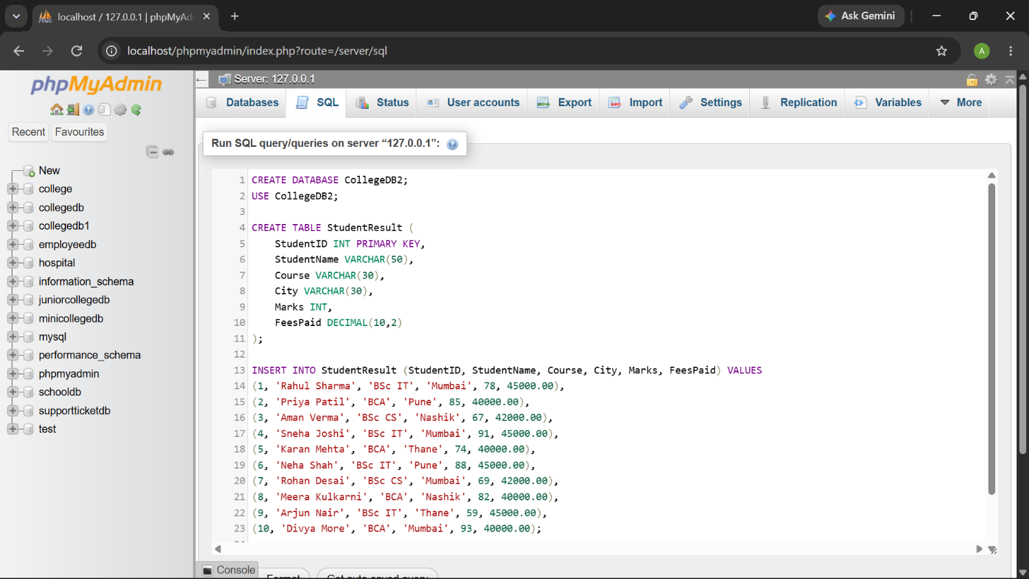
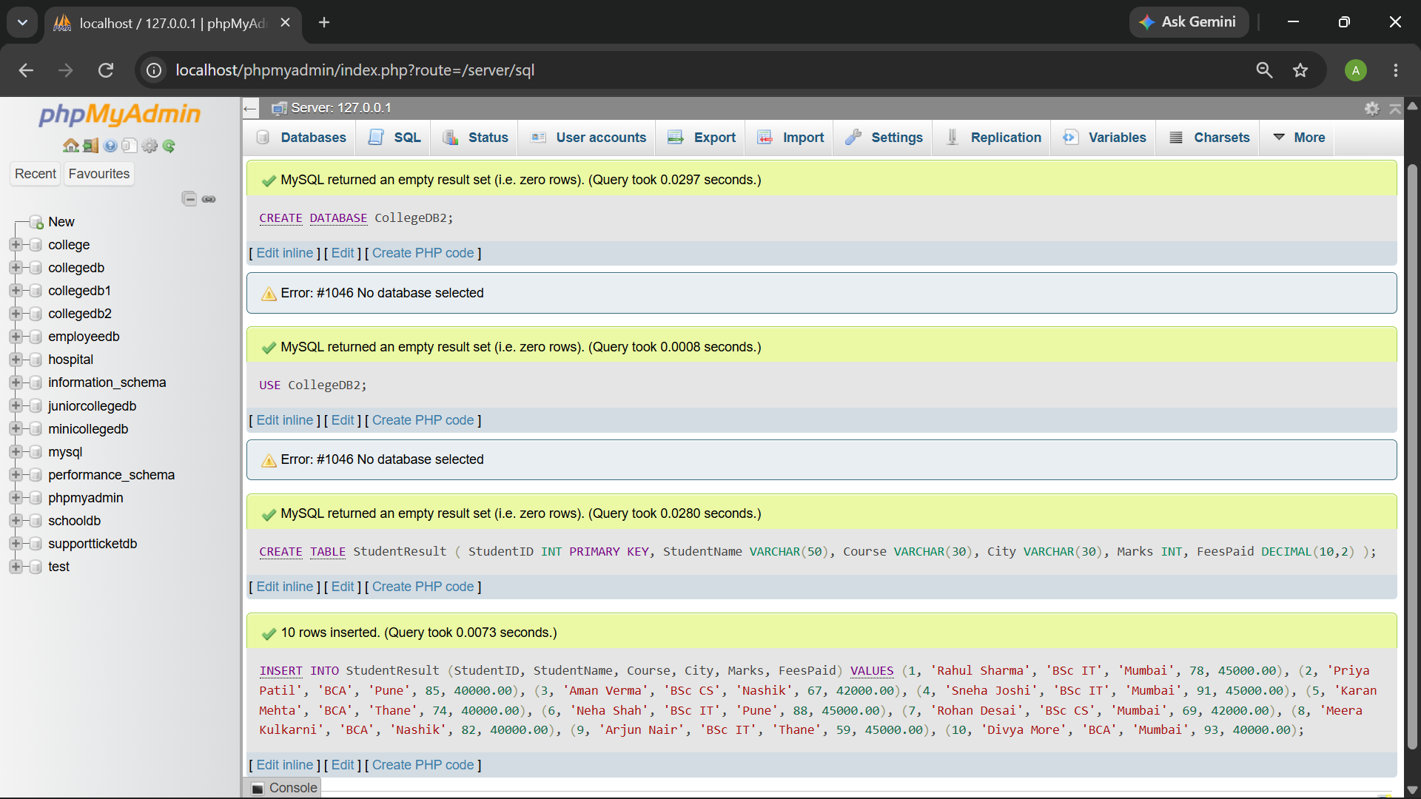

Q2) Write MySQL queries to find the following from the StudentResult table:
Requirement
Total number of students
Total fees paid
Average marks
Lowest marks
Highest marks

QUERY:
-- 1. Total number of students
SELECT COUNT(*) AS TotalStudents
FROM StudentResult;

-- 2. Total fees paid
SELECT SUM(FeesPaid) AS TotalFeesPaid
FROM StudentResult;

-- 3. Average marks
SELECT AVG(Marks) AS AverageMarks
FROM StudentResult;

-- 4. Lowest marks
SELECT MIN(Marks) AS LowestMarks
FROM StudentResult;

-- 5. Highest marks
SELECT MAX(Marks) AS HighestMarks
FROM StudentResult;

OUTPUT:
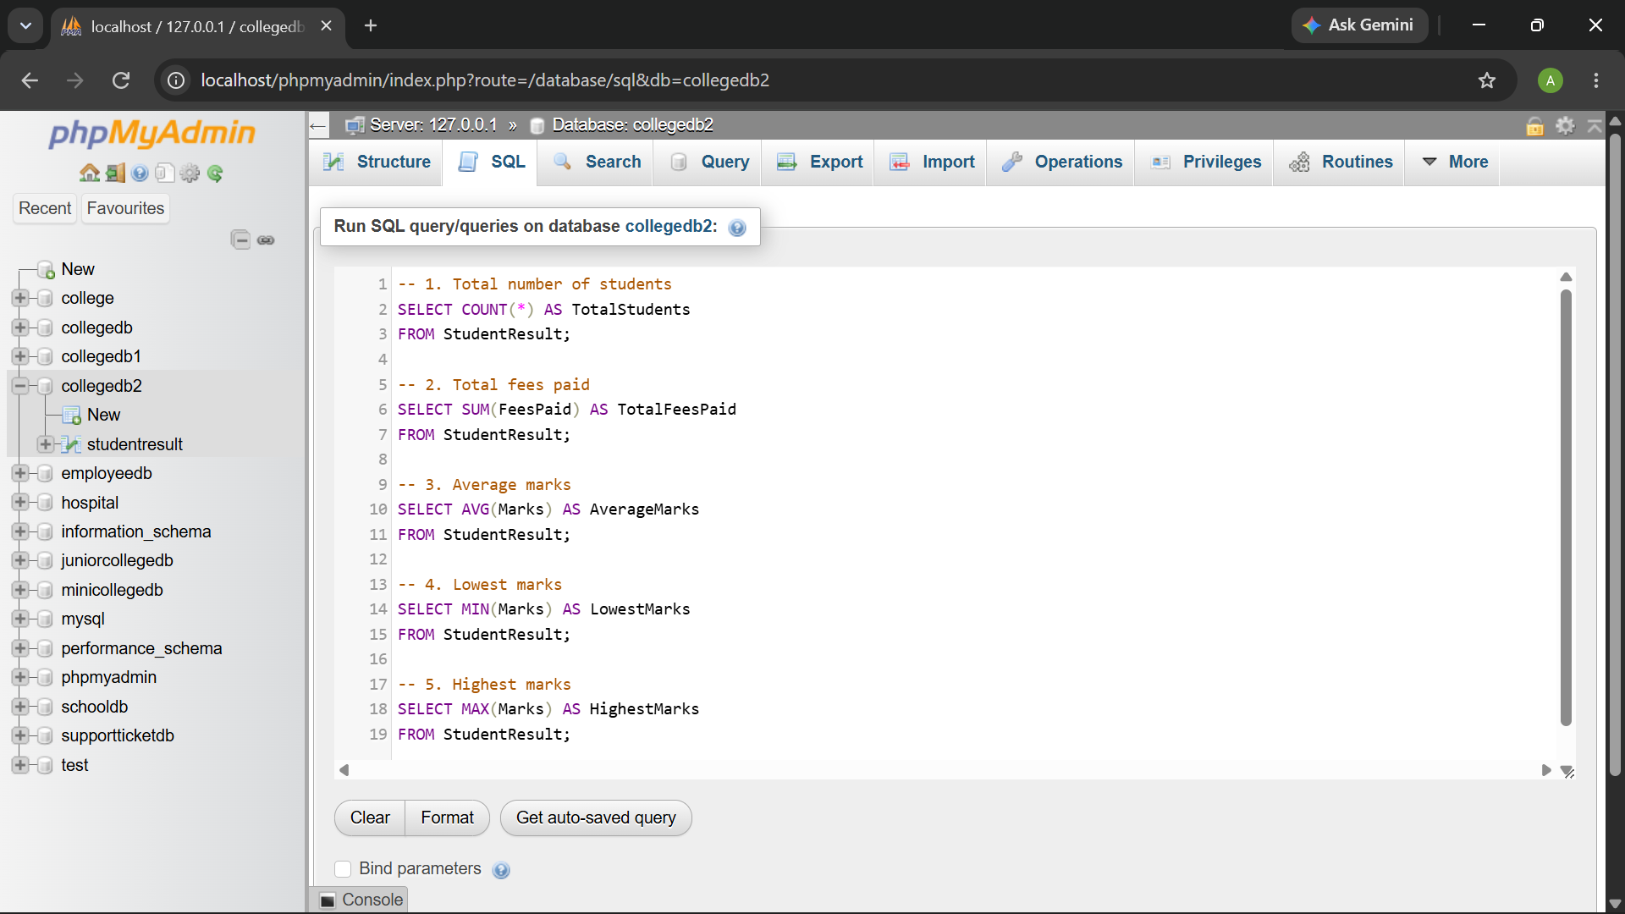
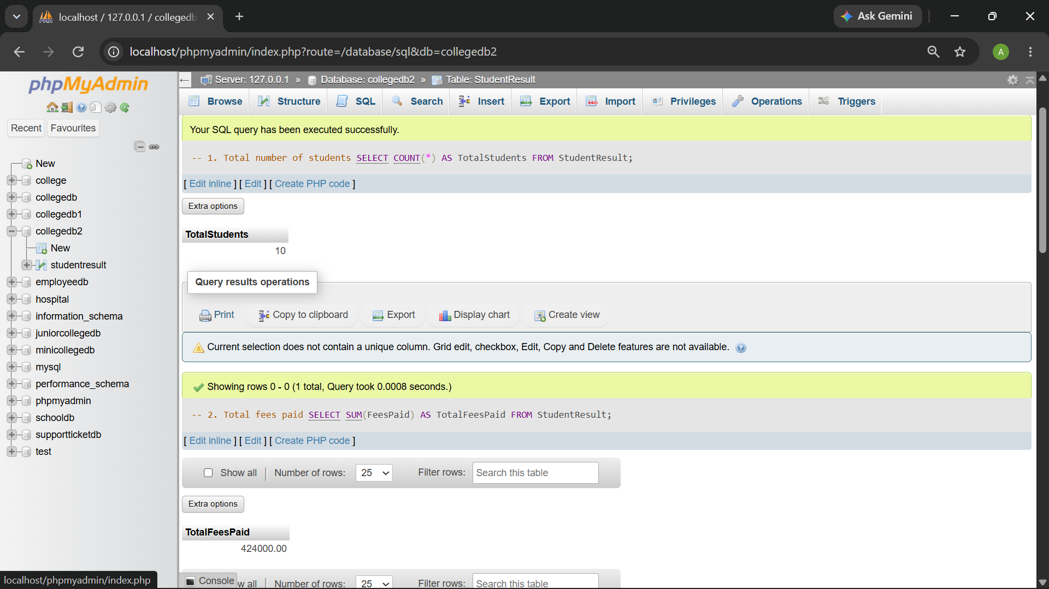
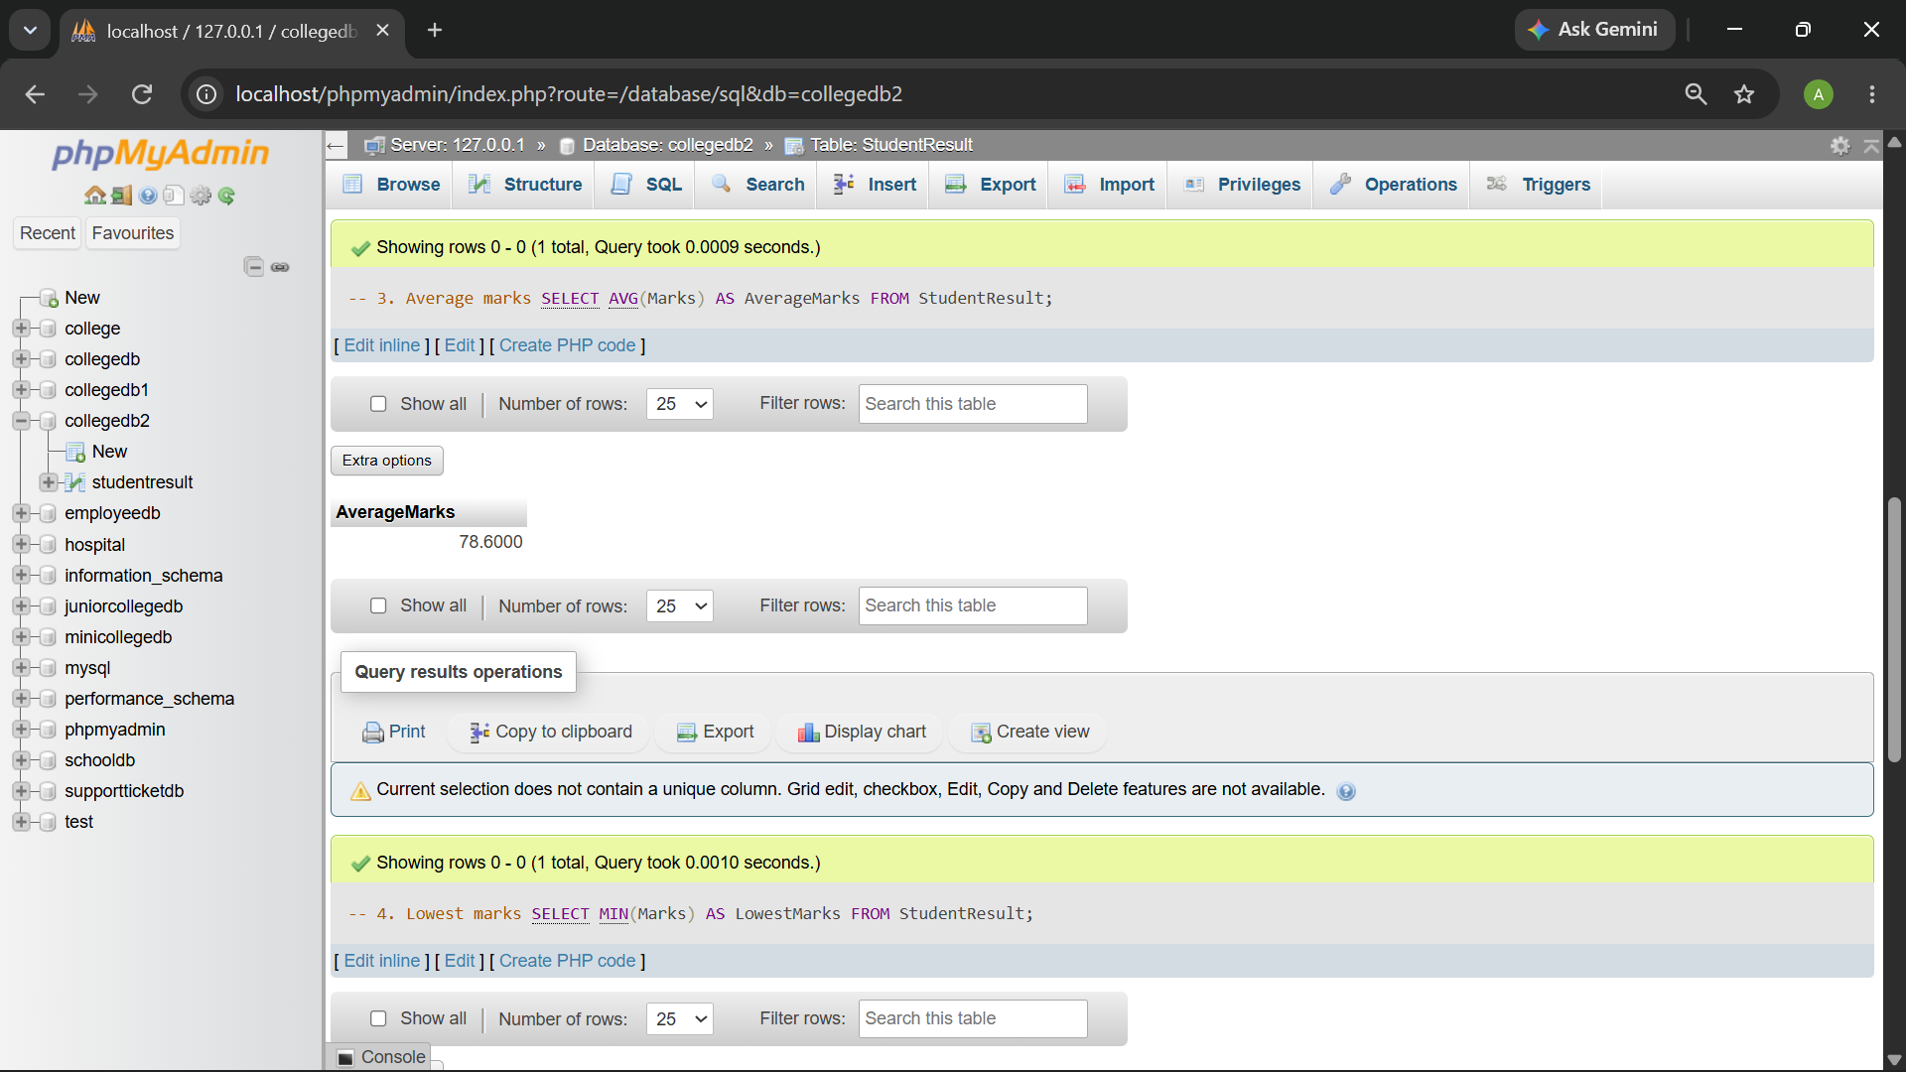

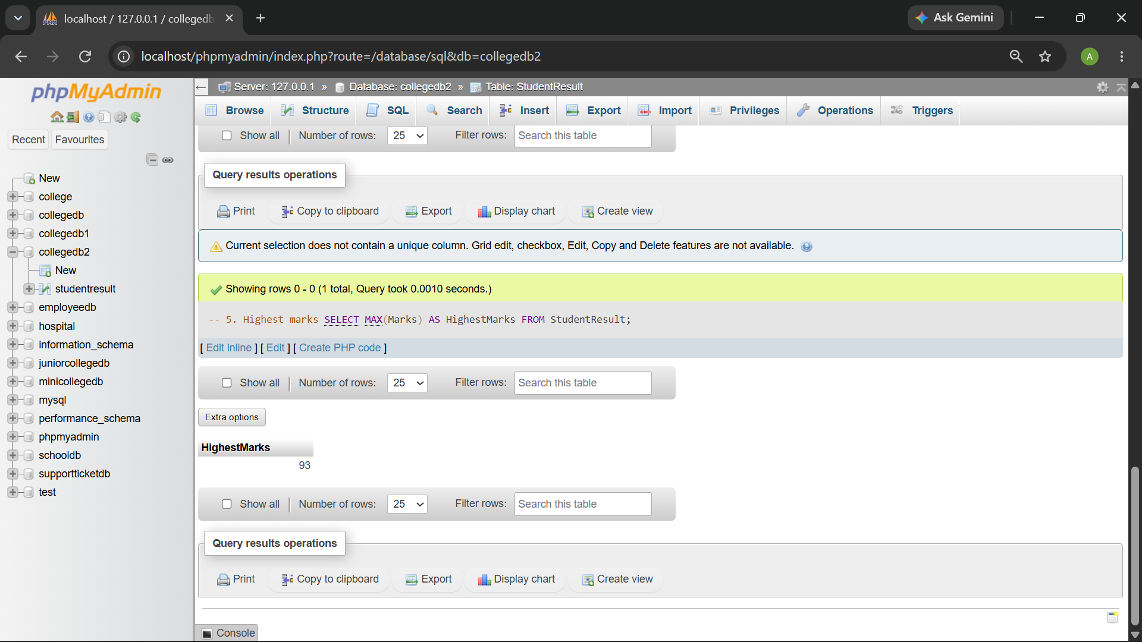

Q3) Write a MySQL query to count the number of students in each course.
The output should contain:
Column
Course
TotalStudents

QUERY:
SELECT Course, COUNT(*) AS TotalStudents
FROM StudentResult
GROUP BY Course;

OUTPUT:
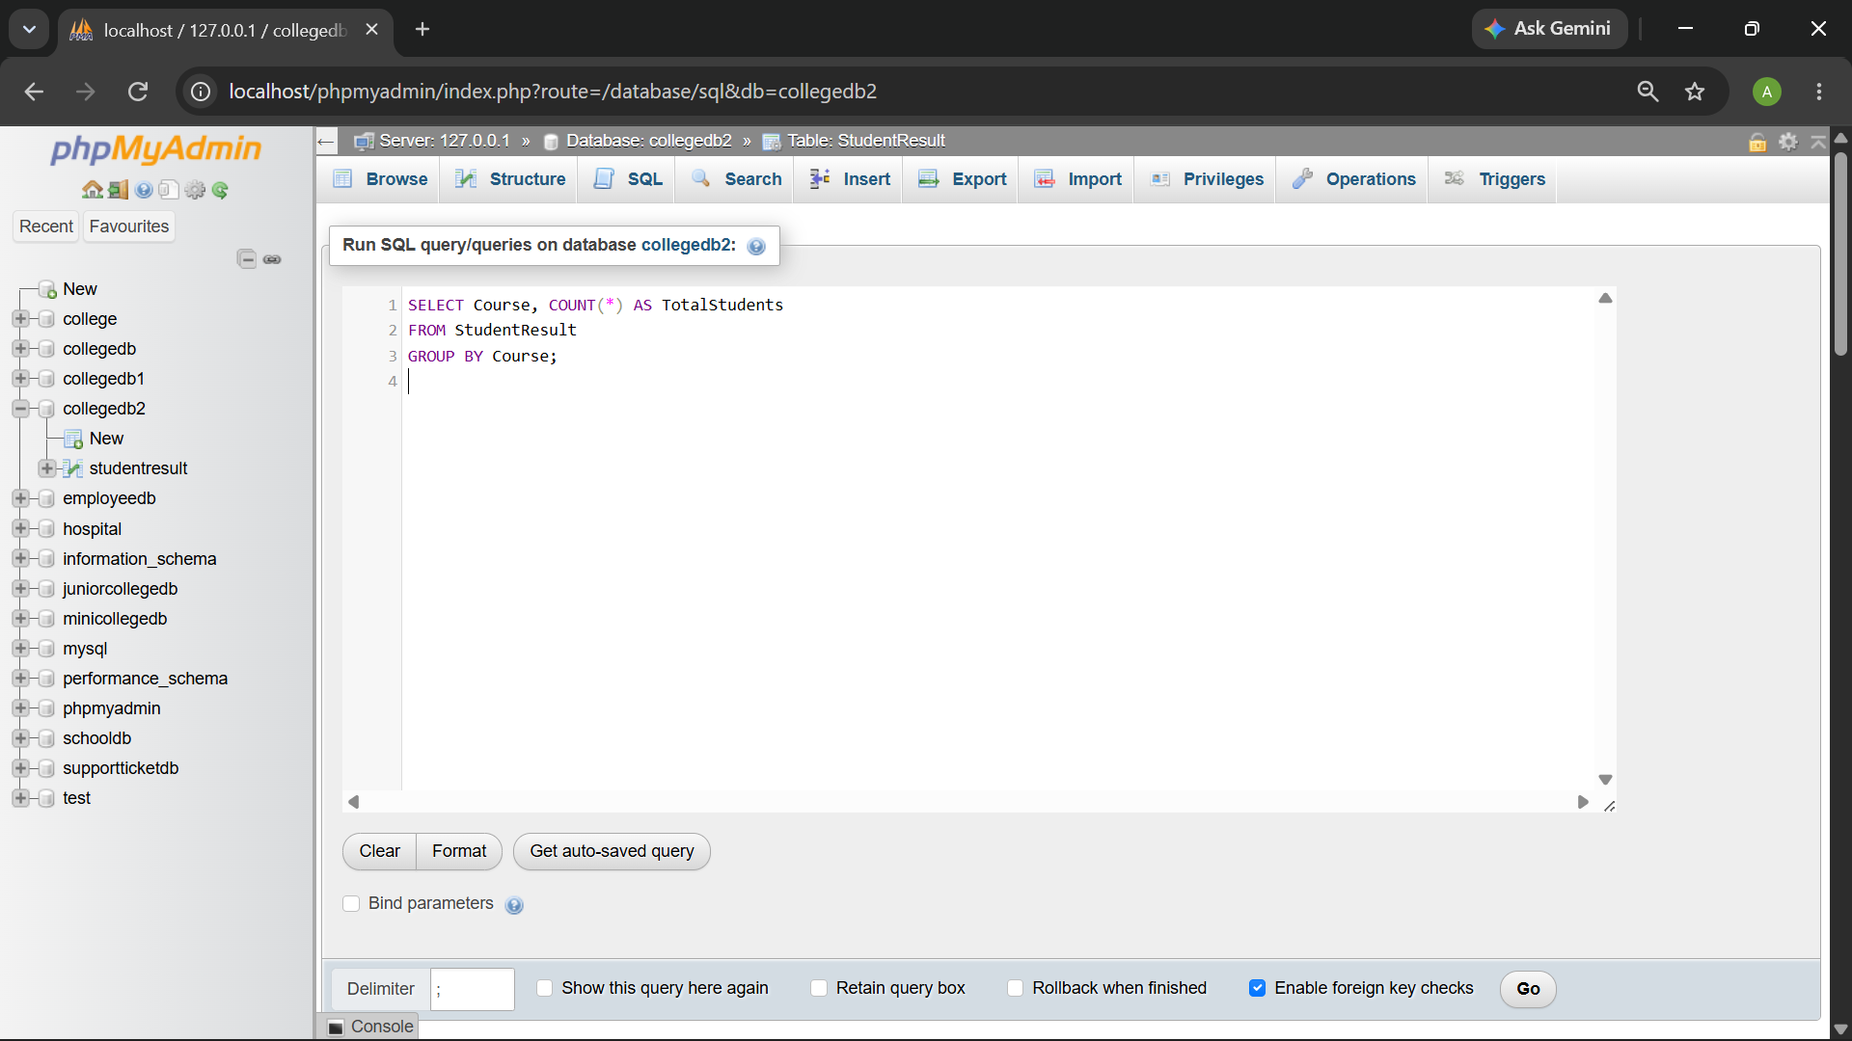
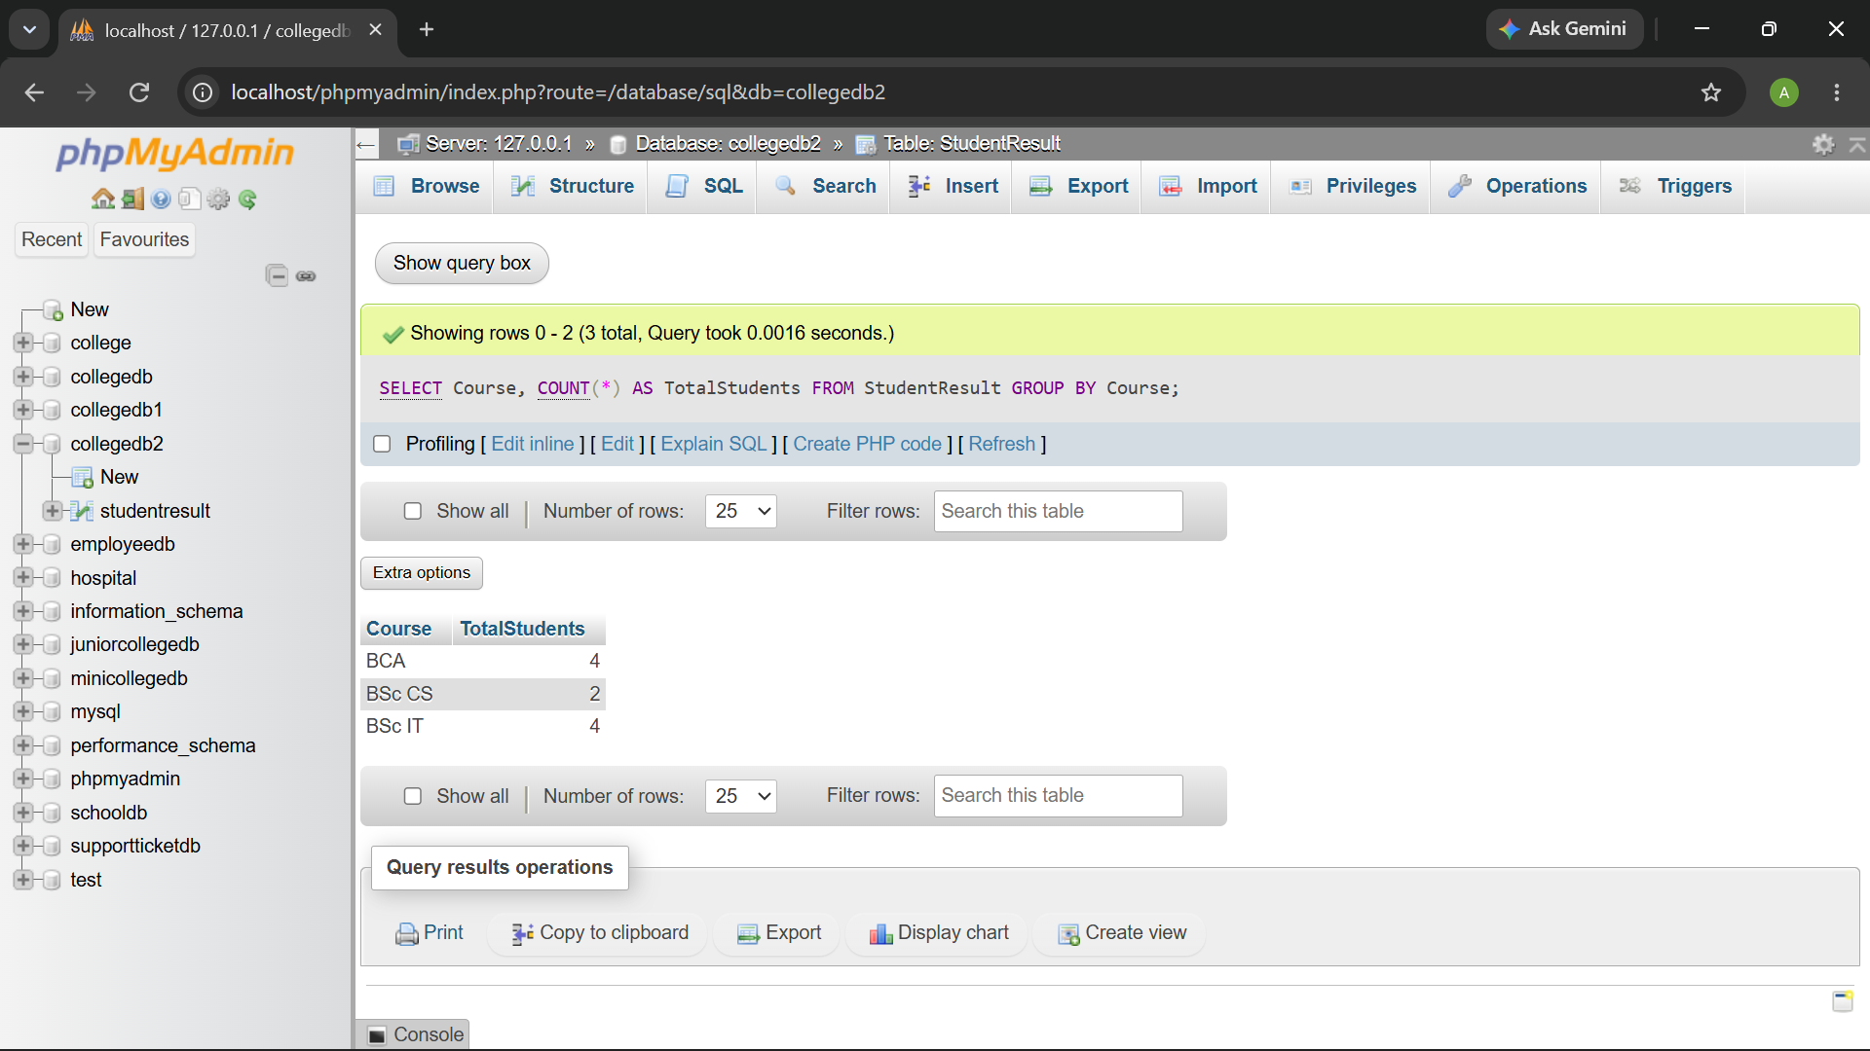

Q4) Write a MySQL query to find the average marks of students course-wise.
The output should contain:
Column
Course
AverageMarks

QUERY:

SELECT Course, AVG(Marks) AS AverageMarks

FROM StudentResult

GROUP BY Course;

OUTPUT:
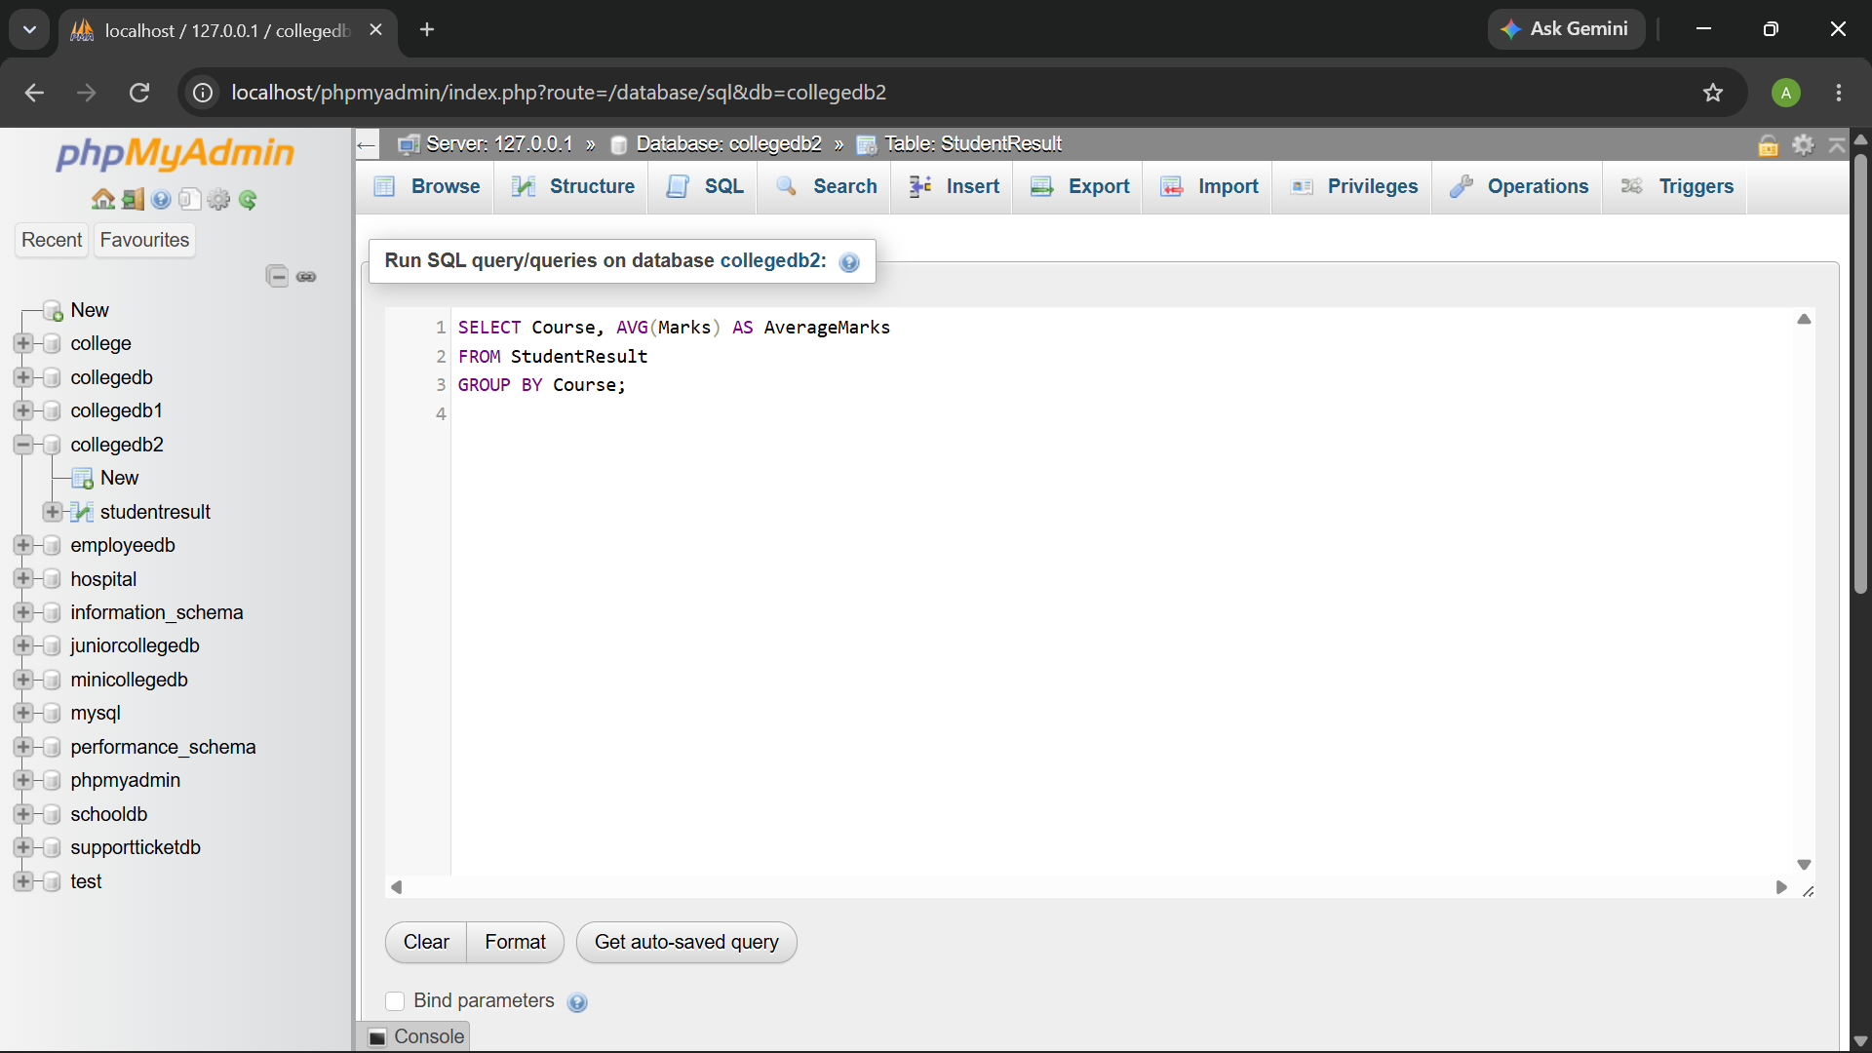
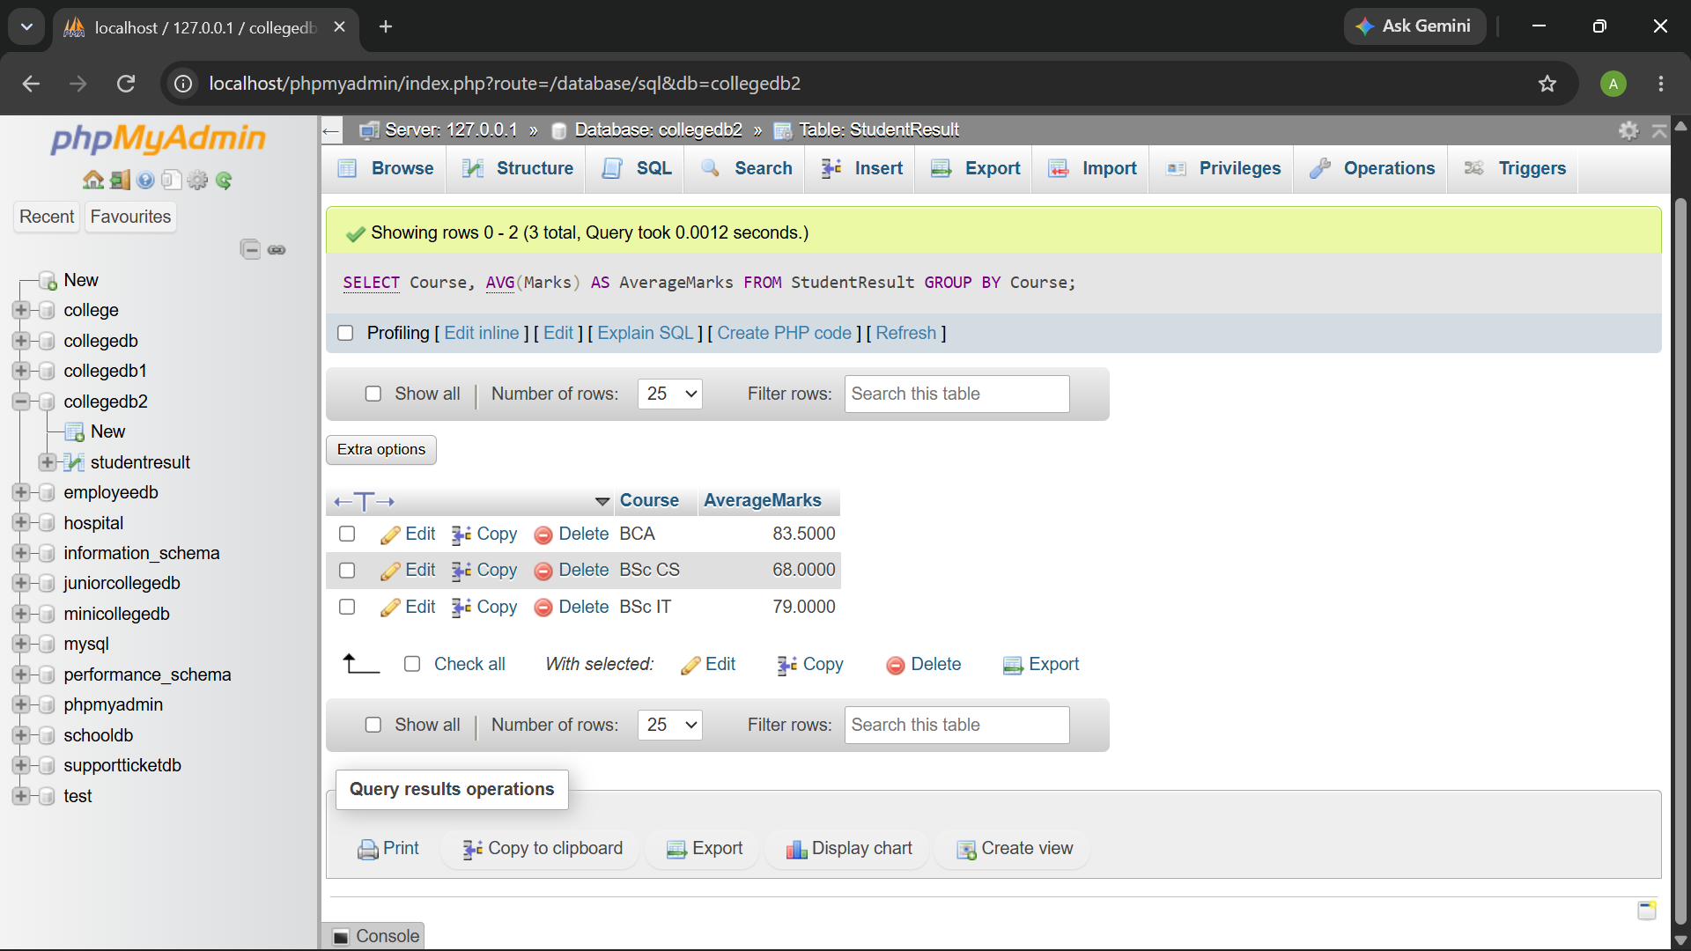

Q5) Write a MySQL query to display only those courses where the number of students is greater than 2.
Use:
Clause
GROUP BY
HAVING

QUERY :

SELECT Course, COUNT(*) AS TotalStudents

FROM StudentResult

GROUP BY Course

HAVING COUNT(*) > 2;

OUTPUT:
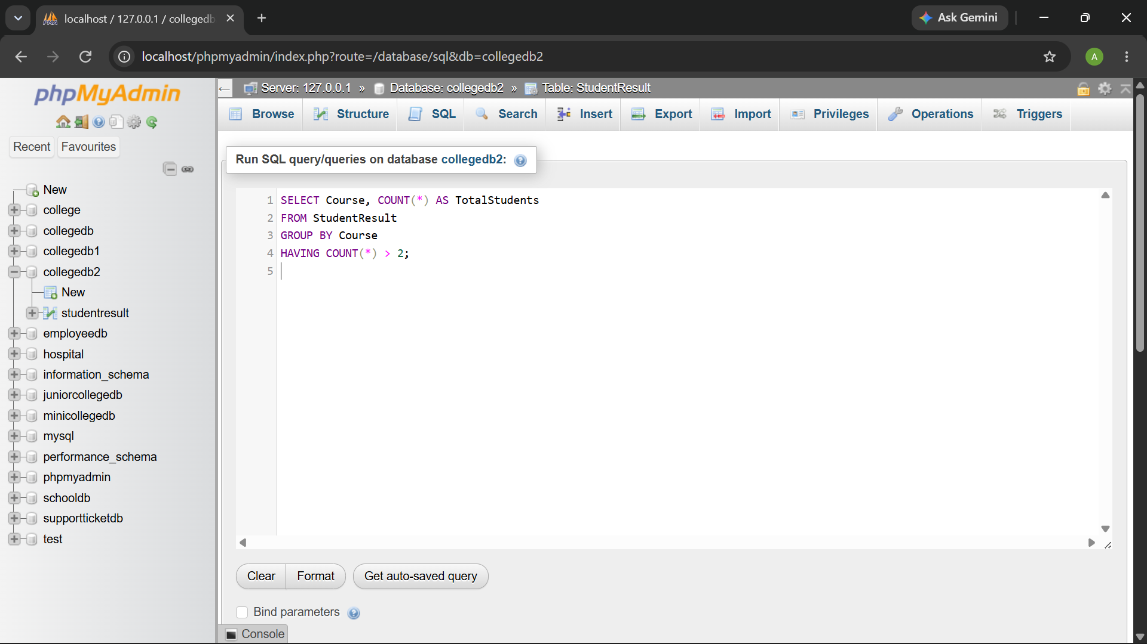
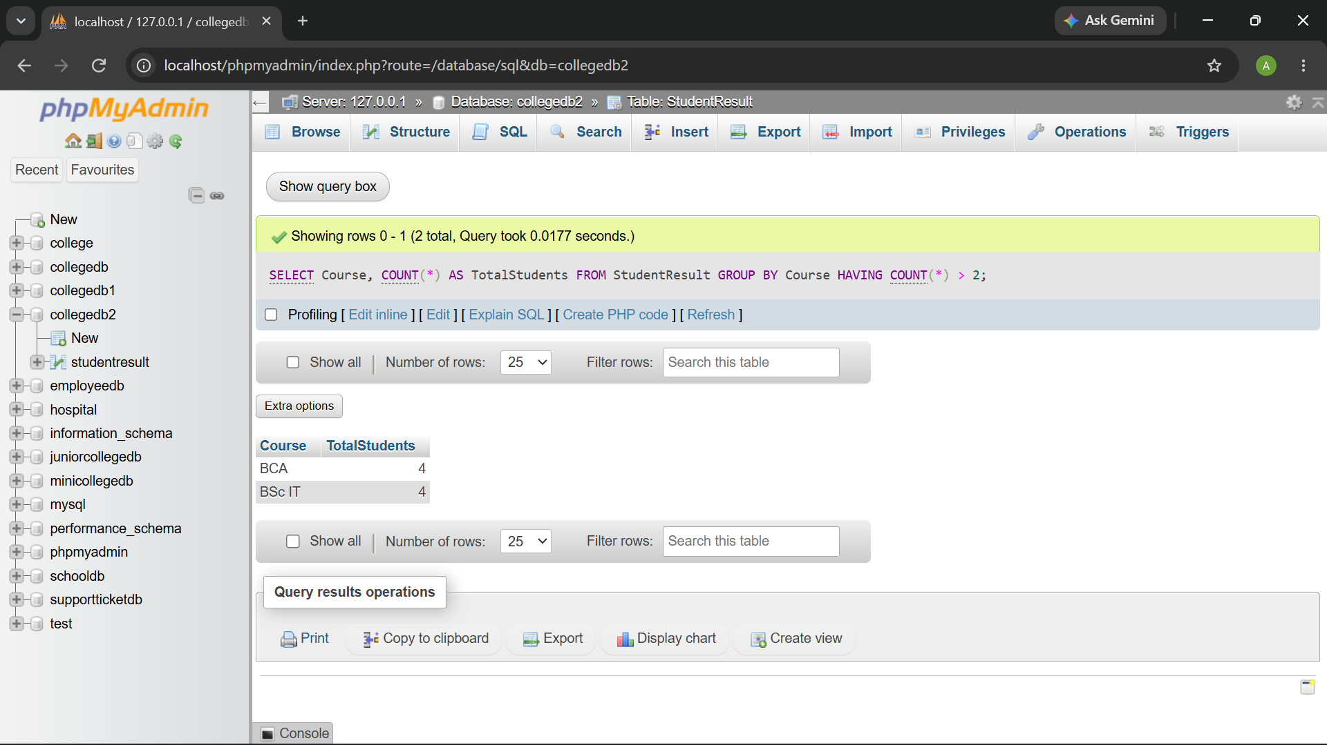

Q6) Write a MySQL query to analyze course performance.
The output should display:
Column
Course
Column
TotalStudents
AverageMarks
LowestMarks
HighestMarks

Sort the result by AverageMarks in descending order.

QUERY:
SELECT
Course,
COUNT(*) AS TotalStudents,
AVG(Marks) AS AverageMarks,
MIN(Marks) AS LowestMarks,
MAX(Marks) AS HighestMarks
FROM StudentResult
GROUP BY Course
ORDER BY AverageMarks DESC;

OUTPUT:

